

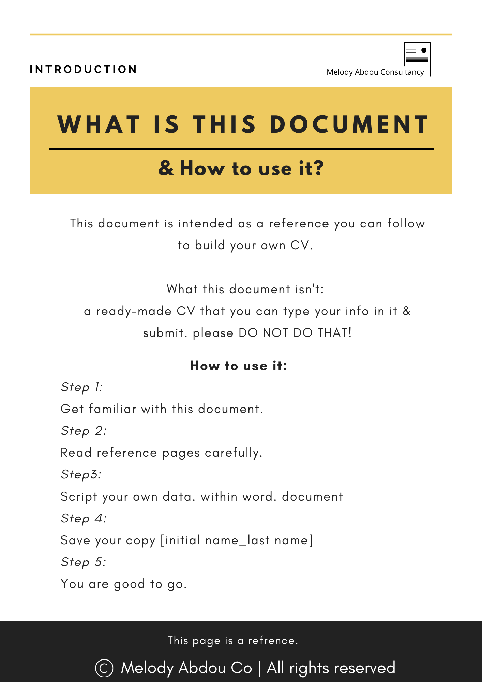
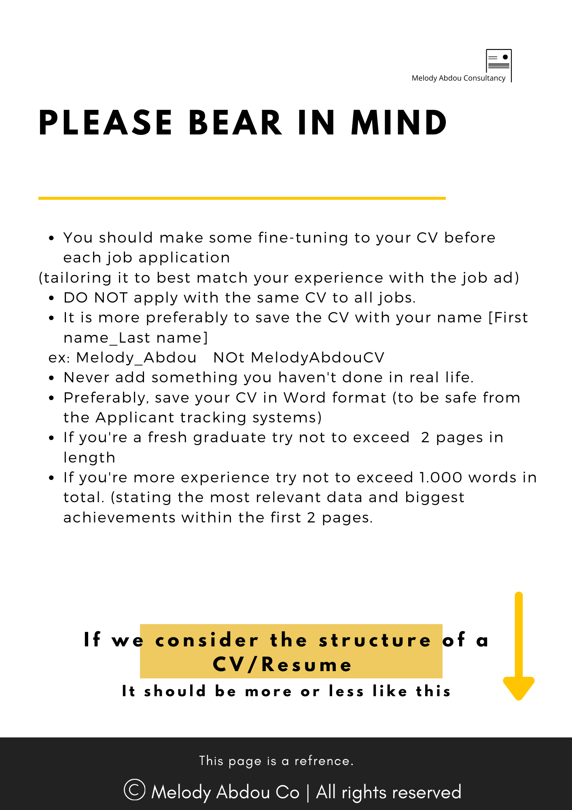
Disclaimer:
In this document you can edit the existing content
By replacing what’s already written with your data
& then delete the unnecessary
- Pages
- Lines
- Shapes
Delete this page & previous one
Template begins at page 5
First Name Last Name
Headline [Title |Department| Industry]
Mobile:
Email:
LinkedIn:
Portfolio:
Publications:
Address:
Military status: (Males only)
Your elevator's pitch
Short, concise paragraph (3-4 lines) about what you do (total years of experience and your specialty or current industry), what's your experience and how you could benefit the company you're applying to. Or [Bullet points of your core competencies – for experienced professionals]
Education
Please move this section below the “Professional Experience” section, in case of having 3+ years of work experience and no recent major study (like a master’s degree or a diploma that would help you make a career shift/jump)
Your Education: Stating the degree-university name and year of graduation in reverse chronological order (newest-to-oldest) [Bachelor’s – Licentiate – Doctorate-& high school] in the following form [delete this line after finishing]
Bachelor’s Degree of Pharmacy & Drug Manufacturing- Alexandria University. Egypt 2014
- Department: Clinical Pharmacy
- Grade: Very Good [3.1 GPA]
Professional Experience
In reverse chronological order (newest-to-oldest) [Delete this line after finishing]
Company name [start date - Present]
(company definition: national/multinational, operating in how many countries, headcount.
International fitness and wellness company, based in KSA, operating in 4 countries in Gulf Region (7+ branches). With employee #1000+
Position title
List your achievements and role within that position (in bullet points)
And what did you contribute during your time? Not just the job description Example:
- Implemented 12% operating and annual maintenance costs reduction for 3 Branches by 12% (4 branches across the Gulf region) shielding a USD 70K reduction, through creating competition within suppliers, requesting quotations, bidding, and contract terms creations and negotiations [2024]
- Spearheaded the company’s business model transition, implemented a Financial raise, shielded working capital for 4 branches and budgeted liabilities, augmented the products portfolio, and introduced new high-end pieces. Securing increased annual sales to 1.7M EGP instead of 800K in 6 months.
Company name [start date - end date]
(company definition: national/multinational, operating in how many countries, headcount.
International fitness and wellness company, based in KSA, operating in 4 countries in Gulf Region (7+ branches). With employee #1000+
Position title
- List your achievements and role within that position (in bullet points)
- What did you contribute during your time? – not just the Job description.
- Example: Realized 95% of initial target settled, and delivered 30% Year Over Year (YOY) revenue growth within a mature market, through contributing in designing and delivery "National Marketing project" for 2024.
Projects
Project a) Project name and at which company you contributed in it – location [date]
Title: your job title.
Brief: Tell us about the project, what was it for and what was the work scale
Scope of Work: (List in bullet points what were your duties for this project) example:
- Supervise work implementation, ensuring design and standards adherence.
- Review Technical drawings and perform correspondence with architecture & electromechanical designs.
Courses & Certificates
- Course name – Institution. [Year]
- List all your courses and certifications [if too many, list the relevant to the job you are applying for only]
Rewards & Recognition
- State them in bullet points and from where you got it if any. If not, then remove this section
Membership
If you belong to a syndicate – please mention it as follow [delete this line]
- Active Membership of the Egyptian Syndicate of Engineers [2024 – Present]
Skills
Professional
- List the work related skills [Branding, Market research, graphic design, corporate communications, sketching, web developer front end.…etc.] in consecutive bullet points

Personal
List the skills related to your character in consecutive bullet points examples below [Choose up to 5 points] and delete this line.
- Perceptive and visionary person with an eye for opportunity.
- Exemplary level of assertiveness and willpower in good decision making.
- Confidence in abilities, demonstrated skills & efficiency at tasks execution.
- Greatly concerned with the collective benefit and sake of the organization.
- Adequate emotional regulation and control within stressful circumstances.
- Strong ethical behavior & moral standards.
- A champion in organizing time effectively and handling multiple tasks efficiently.
- Punctual, focused and sharp with meeting deadlines and managing timelines.
- Able to dissect complex problems into single manageable components.
- Professional implementer of creative process, and good use of imagination to come up with creative ideas.
- Knowledgeable in maintaining forward-thinking and customer-first attitude in dynamic environment.
- Approachable, humble and influential head, calm and in control of oneself.
Technical
- List the skills related to your computer skills
- Microsoft Office [Word, Excel, Power point]
- AutoCAD
- Adobe Premier Pro
- Oracle ERP
- Magento CRM
- SAP
- Opera
Languages
- Arabic [Mother tongue]
- English [Full Professional Proficiency]
- Language C [Full Professional Proficiency] [Moderate Professional Proficiency]
- Language D
Volunteering Experience
- State them in bullet points and have you done in them. If not, then remove this section
Hobbies
- State them in bullet points. – for fresh graduates only.
- If your CV is too long, then remove this section

